Name: Jardel Mitchell

Student ID# 816027213

Question 1 OpenStack Glance (Image Service)

1. Creation of a new Image

Confirmation that image was successfully created.

1. Question 2 Open Stack Dashboard (Horizon)

Project creation

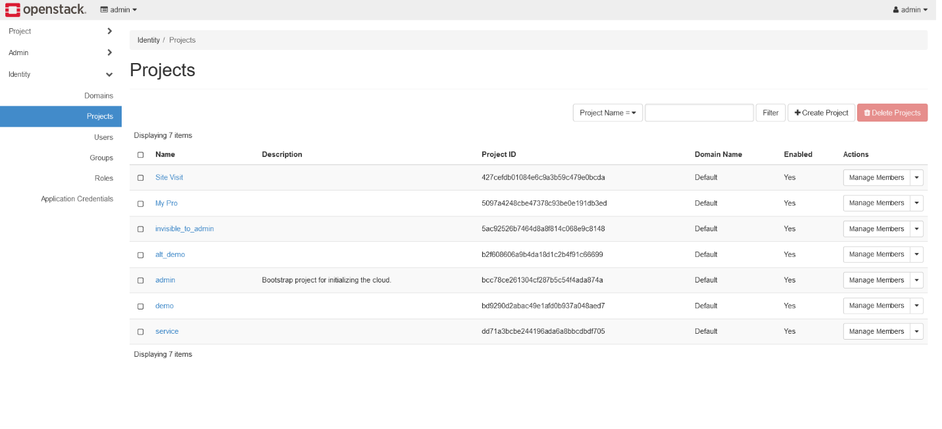

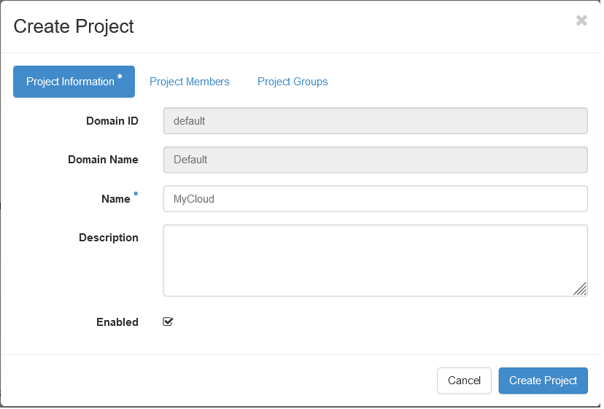

New User created with member permission, password of choice and assigned to MyCloud

Sign in as new User

1. Attempt for creating a volume

1. Attaching a new volume to the previous volume

Attaching a new volume created an error message

Signing back in as an admin

Removal of the “MyCloud” Project and associated resources

1. Question 3 Open Stack Identity Management

Creation of a new Project and User

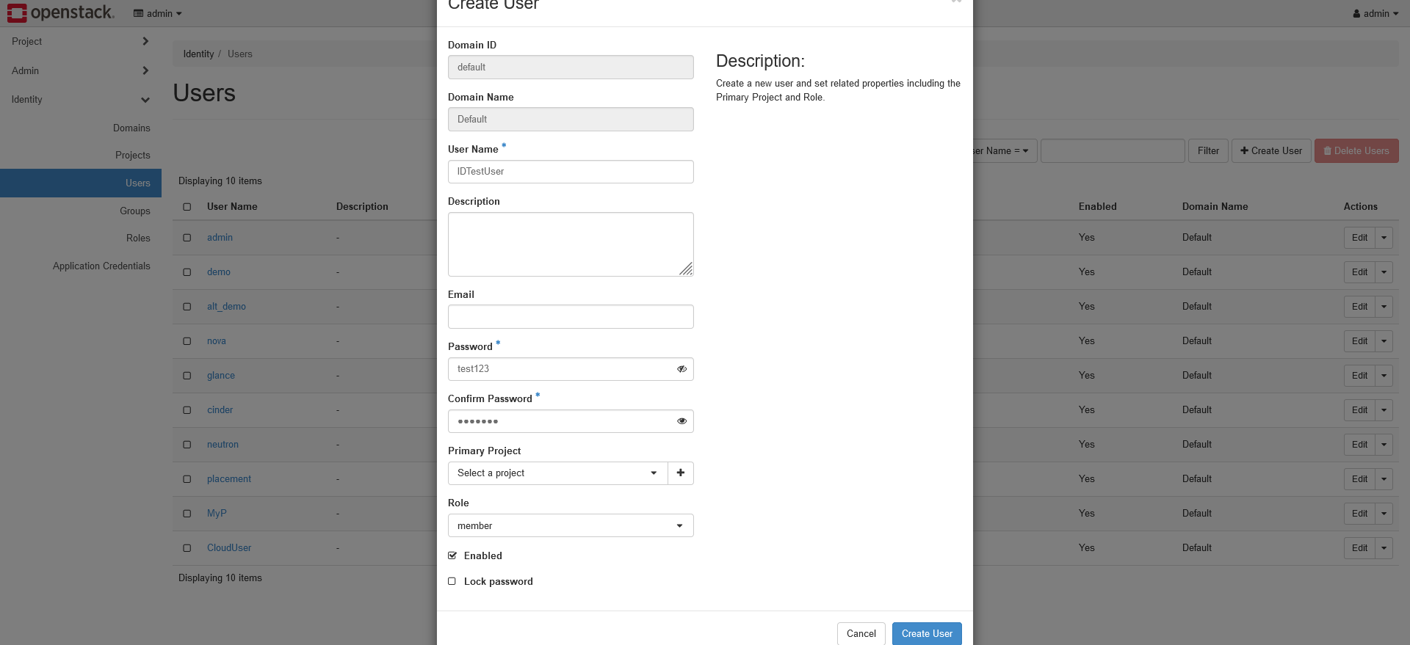

1. Verifying the new user

1. Attempt at deleting the IdentityTest project. The member user was unable to delete the Project. Switched back to admin privilege to delete the Project.

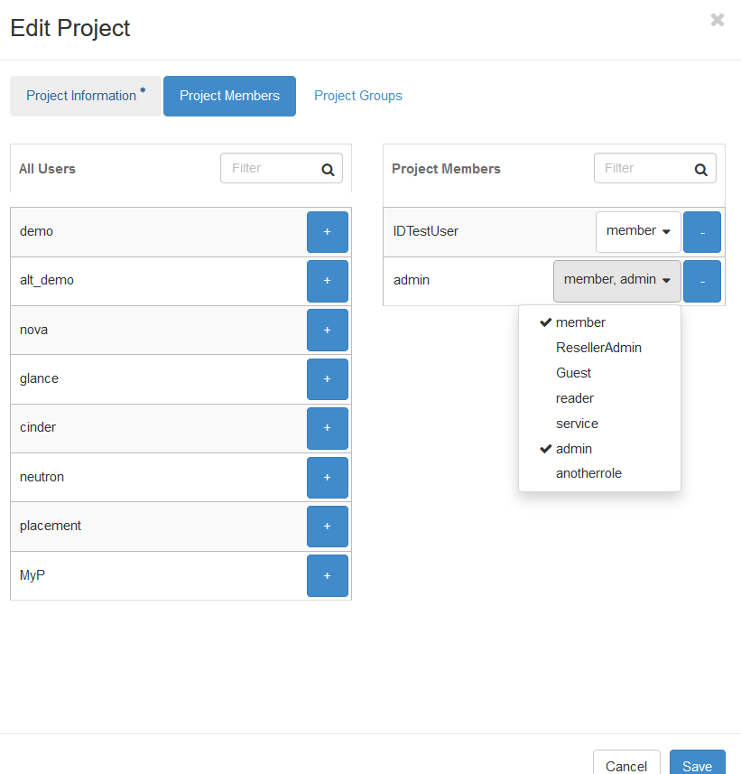

1. Question 4 – Networking

Creation of the network, subnet, router and router interface

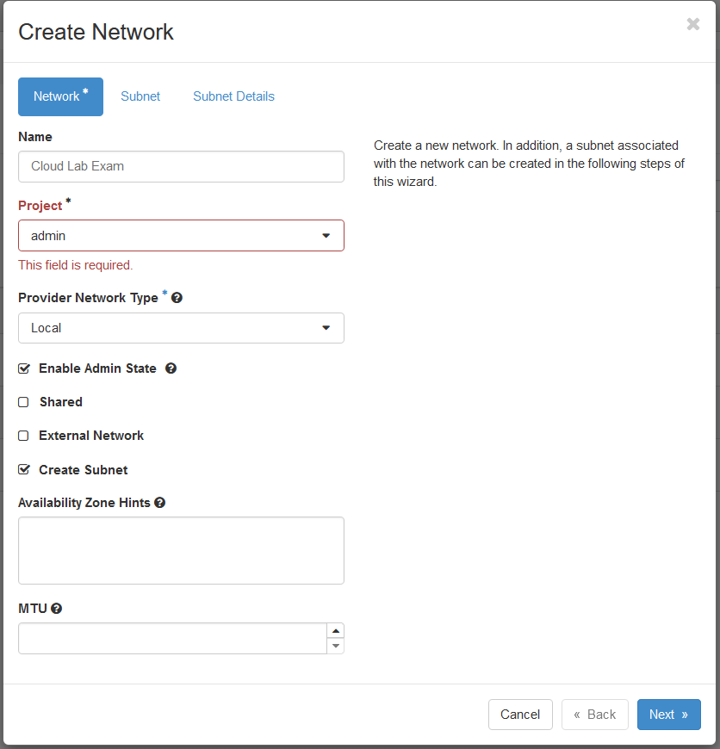

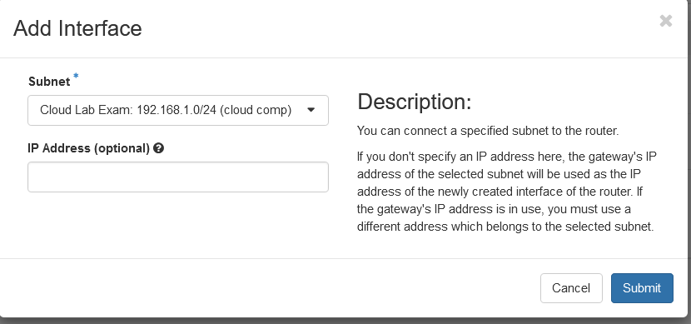

1. Deployment of the Virtual Machine

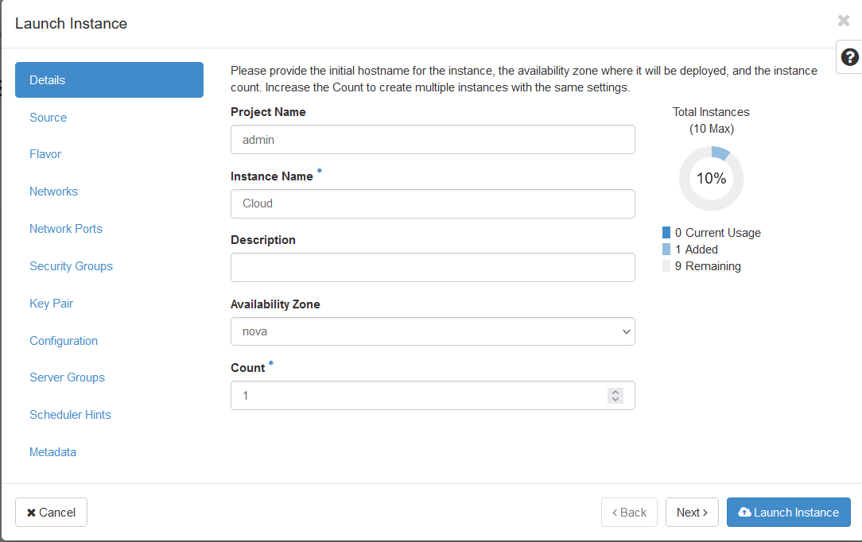

1. Creation of the SSH key pair



Sign out

